SIMATS ENGINEERING
ASSESSMENT TOOL 3: Modelling Comparative Analysis Assignment
COURSE NAME: ARTIFICIAL INTELLIGENCE COURSE CODE: MLA0104
AND EXPERT SYSTEMS

COURSE OUTCOME COVERED
CO 5: Construct rule-based expert systems using production rules, forward and backward chaining, and by distinguishing procedural and non-procedural paradigms across development stages.(BTL 3)
Assessment Tool Weightage: 40%

Total Marks: 100 Time: 90 Mins
No. of Questions: 1
Annexure A
Modelling Comparative Analysis Assignment

Code of Conduct:
I ____________________ (Name / Reg No) certify that this submission is my original work and that I have adhered to the guidelines specified for this assessment.
I understand that any violation of academic integrity rules will result in disciplinary action. Signature of the student:
Criterion | Weightage(%) | Marks Obtained
1. Problem Analysis and Domain Understanding | 10%
2. Domain Knowledge and Fact Identification | 10%
3. Production Rule Modelling | 15%
4. Propositional Logic Modelling | 10%
5. First-Order Logic Modelling | 15%
6. Prolog Modelling and Implementation | 15%
7. Forward and Backward Chaining Demonstration | 10%
8. Comparative Analysis of Modelling Approaches | 10%
9. Results, Discussion and Model Selection | 3%
10. Documentation, GitHub Repository and Presentation | 2%
Total | 100%
Signature of the Faculty Total Marks Awarded

S.No. | Question / Problem Statement
1. | Cybersecurity Threat Detection:  A security operations center wants to identify threats from repeated login failures, unusual login locations, privilege escalation, suspicious file access, and abnormal network traffic. Model the threat-detection problem using production rules, propositional logic, first-order logic, and Prolog, and compare forward and backward reasoning for deriving security conclusions.

Cybersecurity Threat Detection
1. Problem Statement & Objectives
- Problem: Security Operations Centers (SOCs) face high volumes of security alerts (e.g., login failures, traffic spikes). Manual threat triage leads to delayed incident response and missed intrusions.
- Objective: Model a rule-based cyber threat detection system using Production Rules, Propositional Logic, First-Order Logic (FOL), and Prolog. Evaluate data-driven (Forward) versus goal-driven (Backward) chaining to identify optimal threat detection frameworks.
2. Domain Knowledge & Facts
- Entities: User, IP Address, Host, Network Traffic, Security Log.
- Observed Facts (Symptoms/Telemetry):
  - Fact 1: repeated_login_failures (Count > 5 in 1 min)
  - Fact 2: unusual_login_location (Geographic anomaly)
  - Fact 3: privilege_escalation (Unauthorized sudo/admin attempt)
  - Fact 4: suspicious_file_access (Access to /etc/shadow or confidential files)
  - Fact 5: abnormal_network_traffic (High outbound bandwidth / C2 beaconing)
- Diagnostic Conclusions (Threats):
  - Threat A: brute_force_attack
  - Threat B: account_takeover
  - Threat C: insider_threat
  - Threat D: data_exfiltration
3. Production Rule Model
- R1 (Brute Force): IF Event = repeated_login_failures AND Source = external_ip THEN Threat = Brute Force Attack
- R2 (Account Takeover): IF Event = unusual_login_location AND Action = privilege_escalation THEN Threat = Account Takeover
- R3 (Insider Threat): IF Event = suspicious_file_access AND User = standard_employee THEN Threat = Potential Insider Threat
- R4 (Data Exfiltration): IF Event = abnormal_network_traffic AND Action = suspicious_file_access THEN Threat = Active Data Exfiltration
4. Propositional Logic Model
Variables:
- P: Repeated login failures
- Q: Unusual login location
- R: Privilege escalation
- S: Suspicious file access
- T: Abnormal network traffic
- T1: Brute Force
- T2: Account Takeover
- T3: Insider Threat
- T4: Data Exfiltration
Rules & Inference:
- Rules: (P ^ Q) -> T1, (Q ^ R) -> T2, (S ^ T) -> T4
- Modus Ponens Derivation: Given facts S and T: [ (S ^ T) and ((S ^ T) -> T4) ] => T4 (Active Data Exfiltration)
5. First-Order Logic (FOL) Model
- Predicates: User(u), IP(i), DetectsAlert(i, a), HasThreat(u, t)
- Rules:
  - For all u, i: (User(u) ^ IP(i) ^ DetectsAlert(i, LoginFailures) ^ DetectsAlert(i, AnomalyLocation)) -> HasThreat(u, AccountTakeover)
  - For all u, i: (User(u) ^ DetectsAlert(i, SuspiciousAccess) ^ DetectsAlert(i, TrafficSpike)) -> HasThreat(u, DataExfiltration)
6. Prolog Implementation
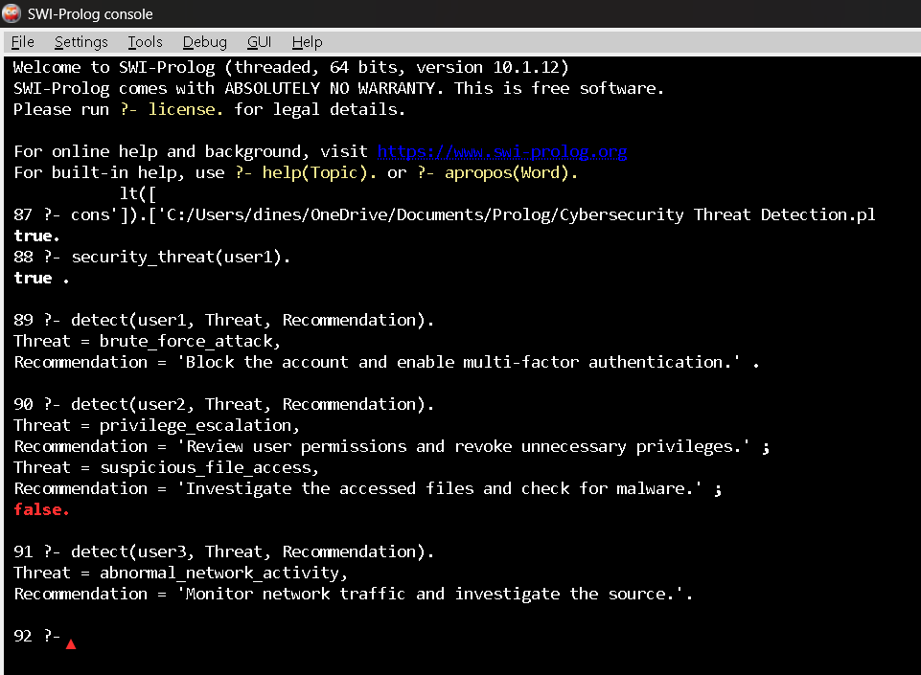
7. Forward & Backward Chaining
- Forward Chaining (Data-Driven / SIEM Monitoring):
  - Input streaming events: suspicious_file_access and abnormal_network_traffic.
  - Match rules against working memory -> Rule for Data Exfiltration fires.
  - Action: Flag host, automatically isolate endpoint, raise high-priority SOC alert.
- Backward Chaining (Goal-Driven / Incident Forensic Investigation):
  - Investigator sets goal: threat(host1, account_takeover).
  - Prove Sub-goal 1: alert(host1, repeated_login_failures) -> Found in KB (True).
  - Prove Sub-goal 2: alert(host1, unusual_login_location) -> Found in KB (True).
  - Output: Goal confirmed True.
8. Comparative Analysis Table
Parameter | ProductionRules | PropositionalLogic | First-Order Logic | Prolog
Knowledge Representation | IF-THEN rules | Boolean variables | Predicates & Quantifiers | Horn Clauses
Expressiveness | Moderate | Low | High | High
Inference Mechanism | Match-Execute | Truth tables / Modus Ponens | Resolution & Unification | SLD Resolution
Forward Chaining | Highly natural for streaming | Supported | Supported | Requires custom interpretation
Backward Chaining | Supported | Supported | Supported | Native default mechanism
Handling Relationships | Limited attribute-value pairs | Poor | Excellent | Excellent
Scalability | High for SIEM streams | Poor (Exponential growth) | Moderate | High
Explainability | High | High | Moderate | High
Ease of Implementation | Very High | High | Low | High
Suitability for Problem | High (Real-time alerting) | Poor | High | Very High (Forensic analysis)
9. Results & Model Selection
- Selection: Prolog / Horn Clause Logic Engine.
- Justification: SOCs require both real-time rule matching and deep threat-hunting capabilities. Prolog seamlessly models multi-hop network relationships (User -> IP -> Endpoint -> Resource) and unifies data quickly during forensic investigations.
- Limitation & Fix: High rate of false positives in static threshold logic. Fix: Integrate machine learning anomaly scores directly into Prolog rule conditions.
10. Conclusion
- Conclusion: Cybersecurity threat detection systems require robust relational models and goal-driven reasoning. Prolog and FOL provide superior expressive power compared to basic propositional models, with Prolog offering the optimal balance of execution speed, relationship management, and practical implementation.
11.References
- Stolfo, S. J., & Salem, M. B. (2024). Rule-Based Expert Systems in Cybersecurity and SIEM Automation. Springer.
- Russell, S., & Norvig, P. (2023). Artificial Intelligence: A Modern Approach (4th Global ed.). Pearson.
- Clocksin, W. F., & Mellish, C. S. (2023). Programming in Prolog: Using the ISO Standard (6th ed.). Springer.
Structure of the Report:
S.No. | Report Section | Expected Content
1 | Problem Statement &  Objectives | Describe the selected real-world problem, domain, decision-making requirement, and objectives of the modelling exercise.
2 | Domain Knowledge &  Facts | Identify entities, attributes, facts, relationships, conditions, and conclusions relevant to the selected problem.
3 | Production Rule Model | Represent the domain using IF–THEN production rules and explain how the rules derive conclusions.
4 | Propositional Logic  Model | Represent the same problem using propositions, logical connectives, and suitable inference statements.
5 | First-Order Logic Model | Represent entities, relationships, properties, and rules using predicates and quantifiers.
6 | Prolog Model &  Implementation | Convert the knowledge into Prolog facts, rules, predicates, and queries. Include relevant code and outputs.
7 | Forward & Backward  Chaining | Demonstrate both reasoning mechanisms using selected facts/goals and provide the inference sequence.
8 | Comparative Analysis  (Table structure given) | Compare the models based on expressiveness, inference mechanism, complexity, scalability, flexibility, explainability, and suitability.
9 | Results, Discussion &  Recommended Model | Analyze the results and justify which approach is most appropriate for the selected real-world problem. Discuss limitations and possible improvements.
10 | Conclusion, References  & GitHub | Summarize findings, provide references, and include the GitHub repository link containing Prolog code, models, test cases, and supporting materials.

EVALUATION RUBRICS

Criterion | Weightage (%) | Excellent | Good | Average | Poor
1. Problem  Analysis and  Domain  Understanding | 10% | 9–10% – Clearly analyzes the real-world problem, domain  entities, constraints, facts, and expected outcomes. | 7–8% – Good understandi ng with minor omissions. | 5–6% – Basic understanding with limited analysis. | 0–4% – Problem is unclear or poorly understood.
2. Domain  Knowledge and  Fact  Identification | 10% | 9–10% – Identifies comprehensive and relevant facts, entities, relationships, conditions, and domain knowledge. | 7–8% –  Identifies most relevant knowledge with minor gaps. | 5–6% – Basic  facts and entities are identified. | 0–4% – Important domain knowledge is missing or incorrect.
3. Production  Rule Modelling | 15% | 13–15% –  Develops accurate, complete, consistent  IF–THEN  production rules that effectively represent the problem. | 10–12% –  Rules are appropriate with minor errors or omissions. | 7–9% – Basic rules are developed but several are incomplete or unclear. | 0–6% – Rules are largely incorrect, incomplete, or inappropriate.
4. Propositional  Logic  Modelling | 10% | 9–10% – Correctly represents domain knowledge using propositions, logical connectives, and valid inference statements. | 7–8% – Good proposition  al representati on with minor errors. | 5–6% – Basic representation with limited logical formulation. | 0–4% –  Representation is incorrect or incomplete.
5. First-Order  Logic  Modelling | 15% | 13–15% –  Accurately models  entities, relationships, properties, variables, predicates, and quantifiers with valid FOL statements. | 10–12% – Good FOL model with minor errors or omissions. | 7–9% – Basic FOL  representation with limited relationships or incorrect usage of some constructs. | 0–6% – FOL model is largely incorrect or missing.
6. Prolog  Modelling and  Implementation | 15% | 13–15% –  Successfully converts the knowledge model into Prolog facts, rules, predicates, and queries with correct outputs. | 10–12% – Functional Prolog implementa tion with minor technical issues. | 7–9% – Basic implementation works but has limited functionality. | 0–6% –  Implementation is incomplete or non-functional.
7. Forward and  Backward  Chaining  Demonstration | 10% | 9–10% – Clearly demonstrates both forward and backward chaining with correct inference sequences and conclusions. | 7–8% – Both mechanism  s are  demonstrat ed with minor gaps. | 5–6% – Basic demonstration with limited reasoning explanation. | 0–4% – Chaining is absent or incorrectly demonstrated.
8. Comparative  Analysis of  Modelling  Approaches | 10% | 9–10% – Provides a detailed and insightful comparison based on expressiveness, inference, complexity, scalability, flexibility, and explainability. | 7–8% –  Provides a meaningful comparison using appropriate parameters. | 5–6% – Basic comparison with limited criteria or analysis. | 0–4% – Little or no meaningful comparison.
9. Results,  Discussion and  Model  Selection | 3% | 3% – Clearly analyzes results and convincingly justifies the most suitable approach for the selected problem. | 2% – Provides good analysis and reasonable justification  . | 1% – Basic discussion with limited justification. | 0% – No meaningful analysis or justification.
10.  Documentation  , GitHub  Repository and  Presentation | 2% | 2% – Report is complete and well structured, GitHub repository is organized, and presentation is professional. | 1.5% – Good documentat ion and presentatio n with minor issues. | 1% – Basic documentation with some omissions. | 0% – Poor documentation, missing repository, or inadequate presentation.
Total | 100%

